**Submitted by : Spogmai Jan**

**Roll No: 2430 – 0081**

**Submitted to: Sir Bilal Dar**

**Subject: Programming Fundamental Lab**

**Assignment No: 04**

**Task 01:**

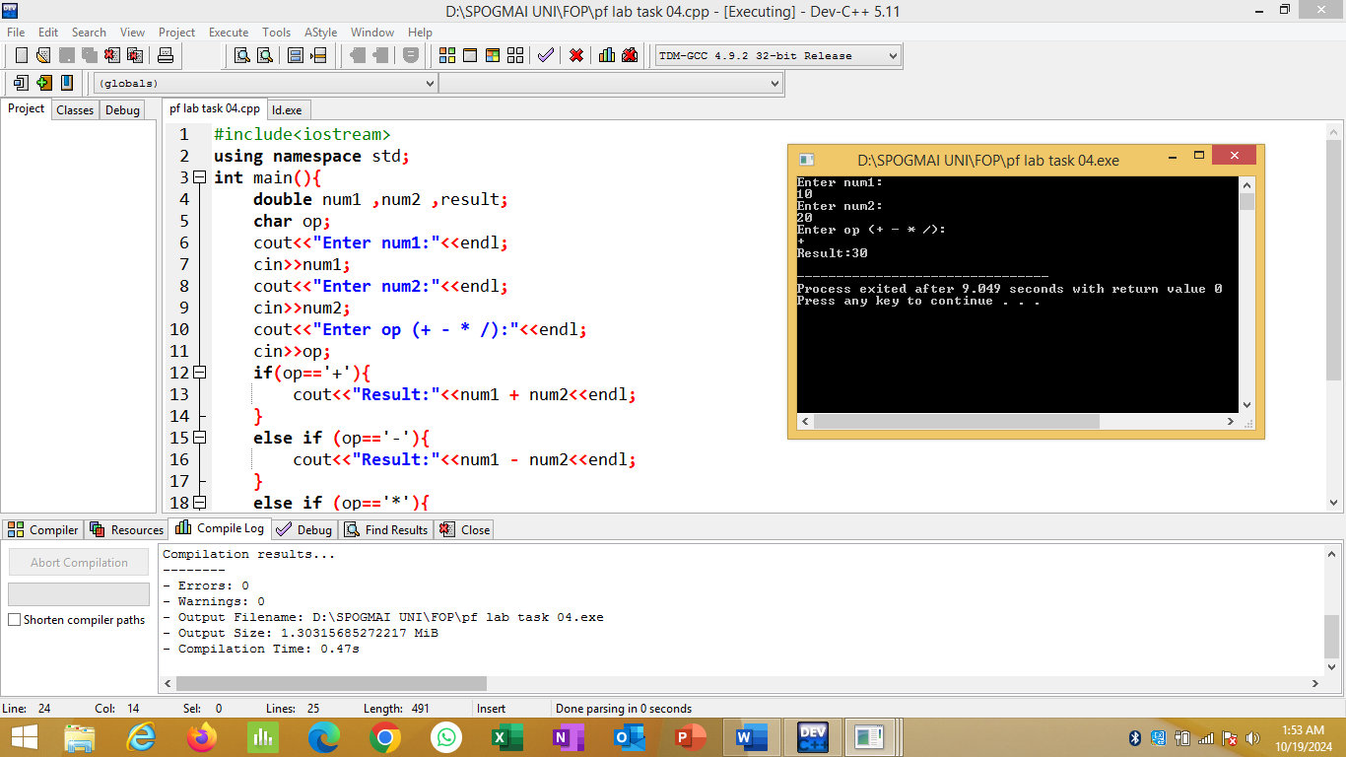

**Task 02:**

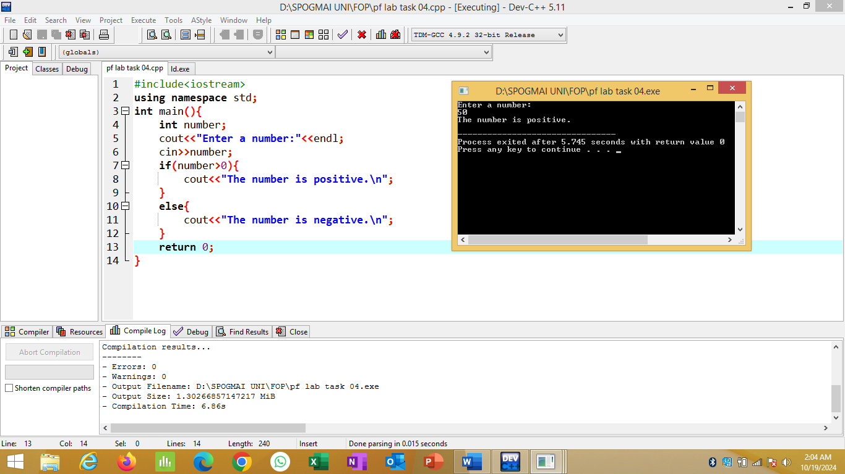

**Task 03:**

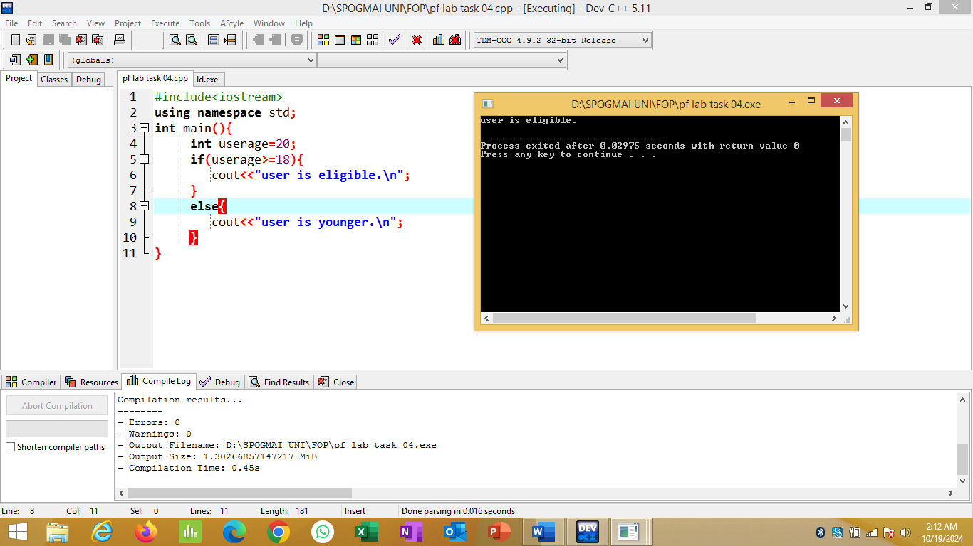

**Task 04:**

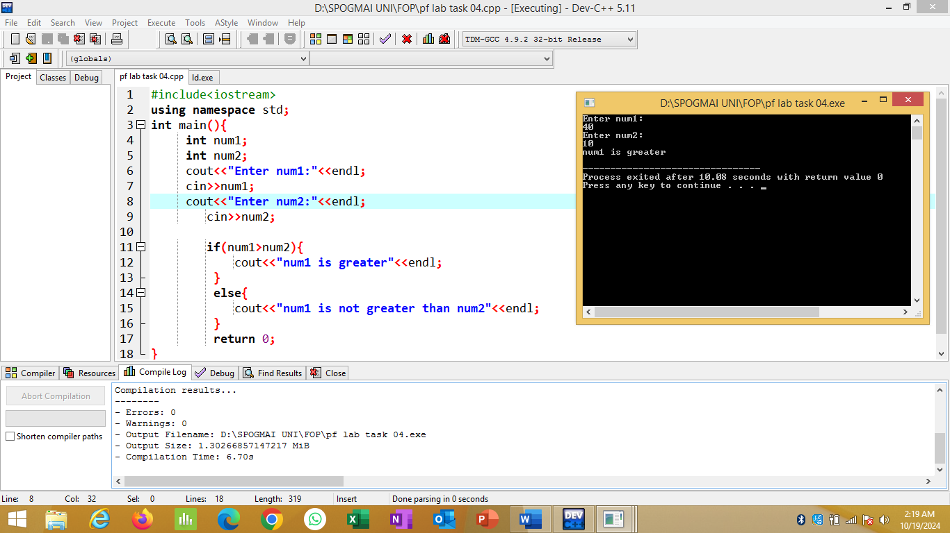

**Task 05:**

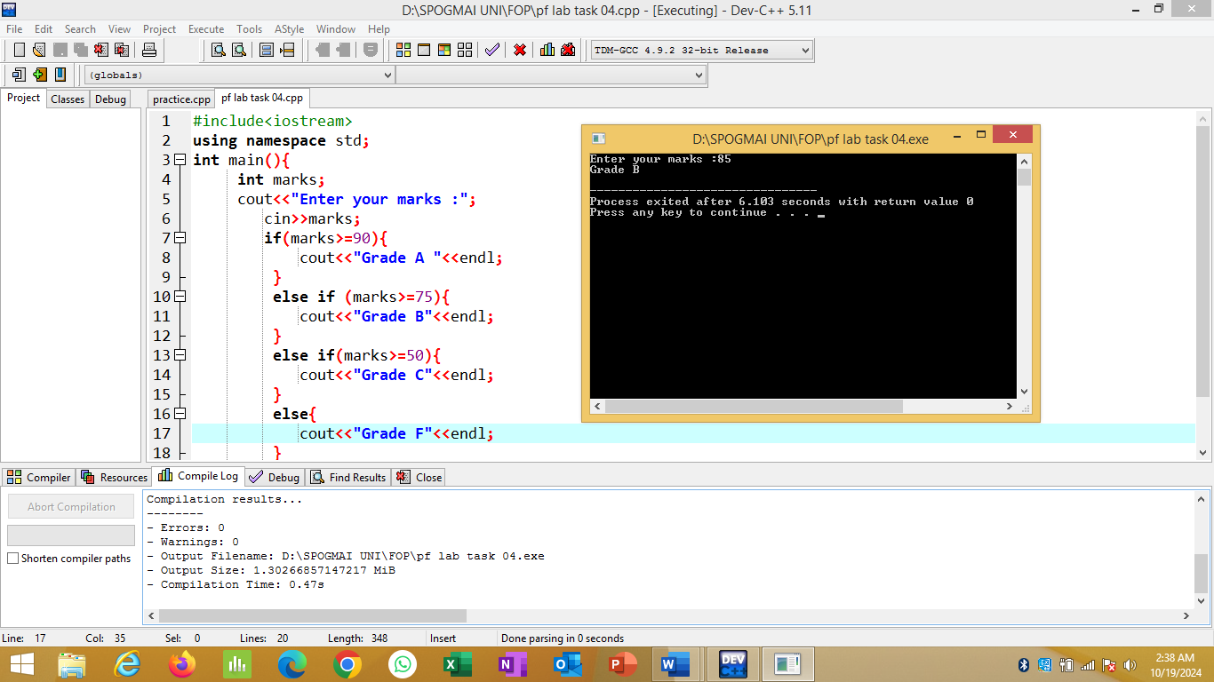

**Task 06:**

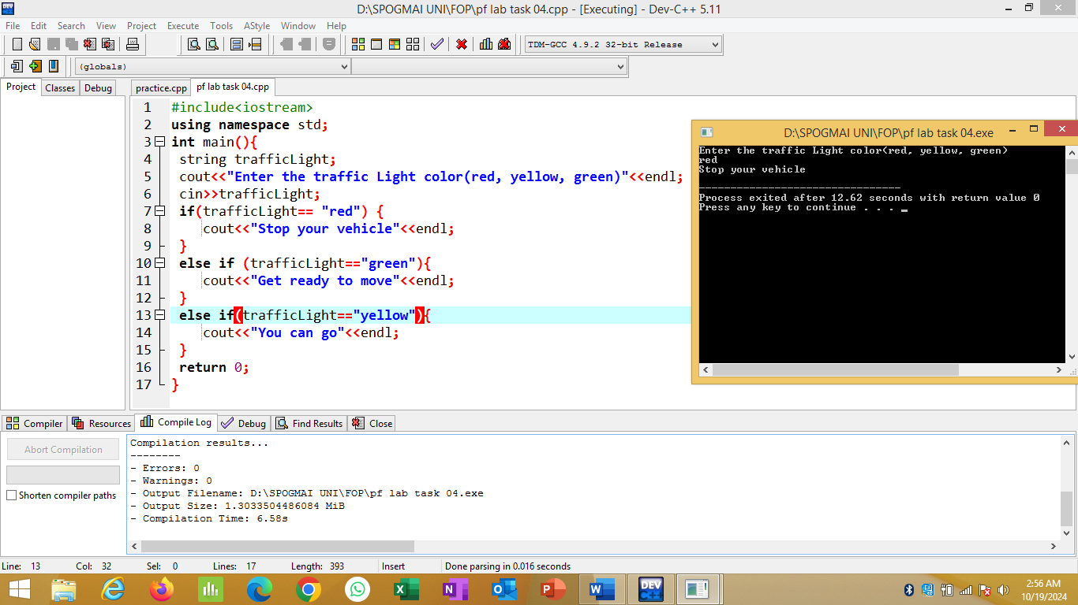

**--The END--**